Lab Experiment: 2

Title: Arduino with Simple Button Interfacing

Course title: IOT Laboratory

Course code: CSE-460
4th Year 1st Semester Examination 2025

Date of Submission: 21/02/2026

Submitted to-

Dr. Md. Ezharul Islam, B.SC.(JU), M.ENGG.(JAPAN), PHD(JAPAN)
Professor
Department of Computer Science and Engineering
Jahangirnagar University

&

Samsun Nahar Khandakar
Assistant Professor
Department of Computer Science and Engineering
Jahangirnagar University
Savar, Dhaka-1342

Class Roll | Exam Roll | Name
383 | 210903 | Abdullah Nazmus-Sakib
379 | 210899 | Shah Sultan
391 | 210911 | Md Khaled Mahmud

1. Objectives
The main objectives of this experiment were:
- To learn how to interface a digital input device (pushbutton) with the Arduino Uno.
- To understand the concept of reading digital states (HIGH/LOW) using the digitalRead() function.
- To control an output device (LED) based on the input status of a pushbutton.

2. Equipment & Components
Based on the lab sheet, the following components were collected:
- Microcontroller: Arduino Uno
- Actuator: LED (Red)
- Sensor/Input: Pushbutton switch
- Resistors:
  - Current limiting resistor for LED (typically 220Ω or 330Ω)
  - Pull-down resistor for Button (labeled 4.7kΩ in Fig. 1)
- Connecting Wires & Breadboard

3. Theory
- Digital Input: Unlike an LED which is an output device, a button is an input device. The Arduino reads the voltage level at the pin to determine if the button is pressed.
- Pull-down Resistor: In this circuit, a 4.7kΩ resistor is used as a "pull-down" resistor. It ensures that when the button is not pressed, the input pin reads 0V (LOW). Without it, the pin might float and give random readings.
- Logic:
  - Button Pressed: 5V flows to the pin $\rightarrow$ Arduino reads HIGH.
  - Button Released: Pin connects to Ground via resistor $\rightarrow$ Arduino reads LOW.

4. Procedure
- Component Collection: We gathered the necessary components listed in the requirements.
- Circuit Connection: We built the circuit on the breadboard according to Fig. 1:
  - LED: Anode connected to Pin 12; Cathode connected to Ground (GND).
  - Button: One side connected to 5V; the other side connected to Pin 2 and to Ground via the 4.7kΩ resistor.
- Programming: We opened the Arduino IDE and navigated to File > Examples > Digital > Button as a reference, then adapted the code to match our pin configuration (Pin 2 for button, Pin 12 for LED).

5. Source Code
The following code was uploaded to the Arduino board:
C++
const int buttonPin = 2; // the number of the pushbutton pin
const int ledPin = 12; // the number of the LED pin

int buttonState = 0; // variable for reading the pushbutton status

void setup() {
pinMode(ledPin, OUTPUT); // initialize the LED pin as an output
pinMode(buttonPin, INPUT); // initialize the pushbutton pin as an input
}

void loop() {
// read the state of the pushbutton value:
buttonState = digitalRead(buttonPin);

// check if the pushbutton is pressed. if it is, the buttonState is HIGH:
if (buttonState == HIGH) {
// turn LED on:
digitalWrite(ledPin, HIGH);
} else {
// turn LED off:
digitalWrite(ledPin, LOW);
}
}

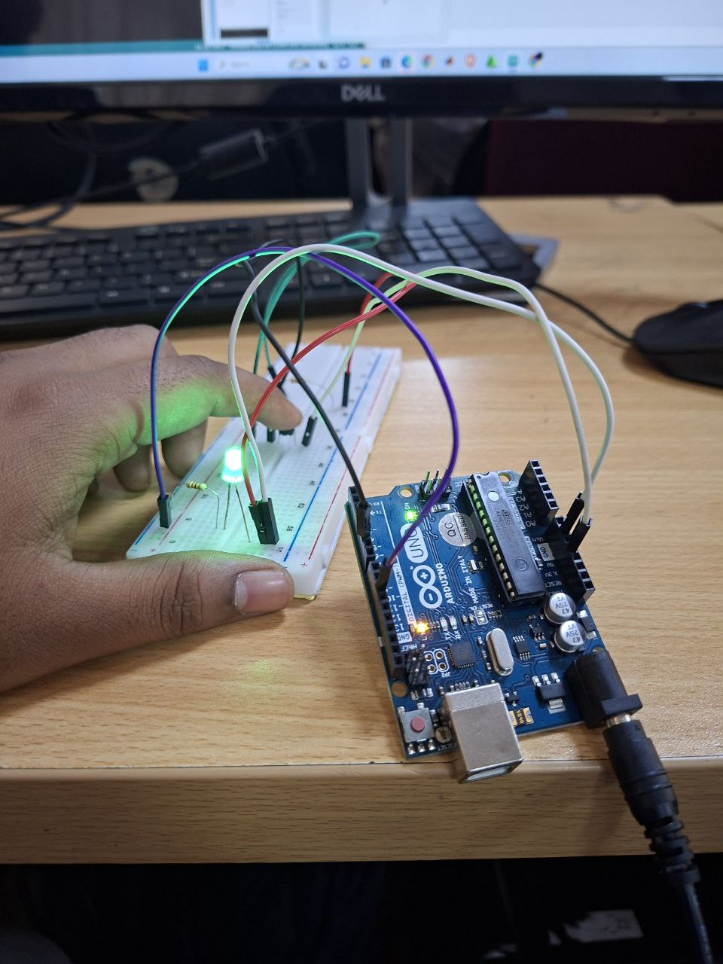
6. Circuit Analysis (Fig. 1)

The schematic provided in the lab sheet illustrates:
- Pin 12 (Output): Sends voltage to the LED when the code instructs it to turn on.
- Pin 2 (Input): constantly monitors the voltage.
- Resistor Configuration: The 4.7kΩ resistor (R2) is critical. It creates a default state of "LOW" for Pin 2. When the switch closes, the direct connection to 5V overpowers the weak connection to the ground, pulling the pin "HIGH".

7. Observation & Conclusion
Observation:
- When the system was powered on, the LED remained OFF initially.
- When the pushbutton was pressed and held, the LED turned ON.
- When the pushbutton was released, the LED immediately turned OFF.
Conclusion:
We successfully interfaced a pushbutton with the Arduino. We learned how to configure a GPIO pin as INPUT and use conditional statements (if/else) to control an output based on real-time user input. This experiment demonstrates the fundamental logic required for controlling devices via switches.

